**Activity 10**

**Read the text and answer the questions. Circle in red all the personal pronouns, yellow for all the articles (definite and indefinite) and add the words you don’t know to the glossary section in this assignment.**

**No, she goes to bed late**

**Yes, she does**

**After work**

**She works at ten**

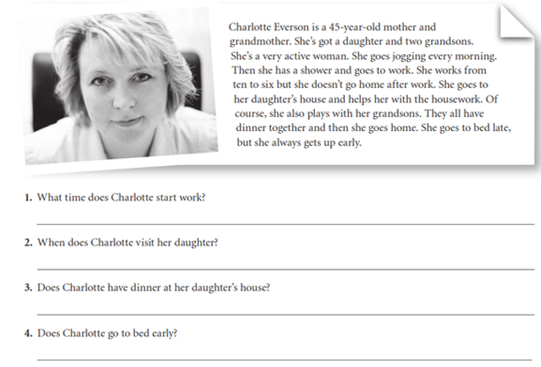

Bibliography:

Mitchell H.Q., (2010). *Traveller - Elementary - Test Booklet*. MM publications.

Glossary

|  |  |  |  |
| --- | --- | --- | --- |
| **Word or expression** | **Meaning in English** | **Meaning/Translation in Spanish** | **Type** |
| **Example:**  Good morning | Greeting to express good wishes on meeting or parting during the morning. | Buenos días | Greeting |
|  |  |  |  |
|  |  |  |  |
|  |  |  |  |
|  |  |  |  |
|  |  |  |  |
|  |  |  |  |
|  |  |  |  |
|  |  |  |  |
|  |  |  |  |
|  |  |  |  |
|  |  |  |  |